“This is the site for learning about democracy.”¹  “A huge contribution to the democracy cause.”²  See How  The best voting rules are fast, easy and fair.  They help groups from classrooms to countries.  The results are well centered and widely popular.  They strengthen the votes supporting  $ $ $  $ $ $  $ $ $  one chairperson or policy and  fair shares of seats or $.  1  y  Then Act  Share this colorful booklet with friends. Build support in your school, club or town with FairVote.org  AccurateDemocracy.com/eBook.pdf | Bert Lo  22902-5447 | POSTAL  INDICIA  FairVote  8484 Georgia Avenue,  Suite 240,  Silver Spring, MD 20910  Barcode and Post Office Markings  .  Fair $hare Voting  .  for Schools, Clubs, Towns & More | Accurate  Democracy  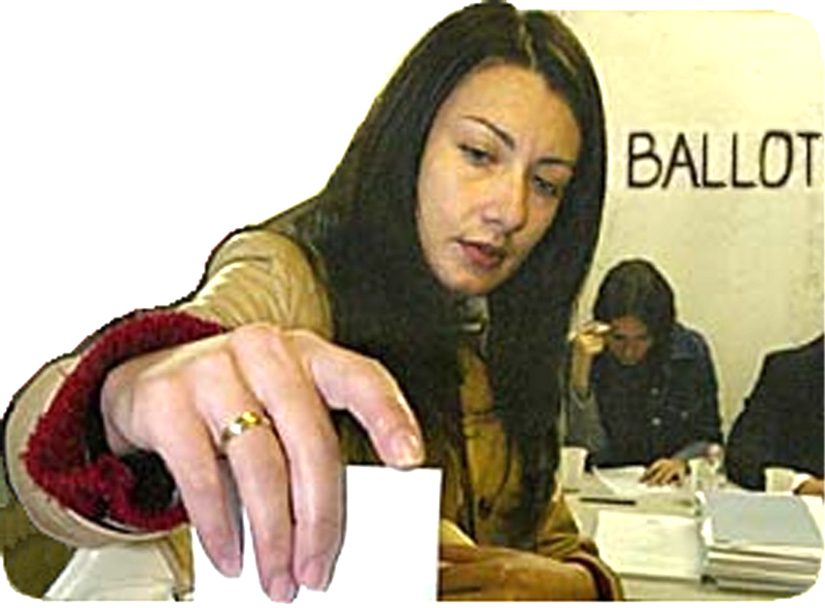  New tools  help democracy boost  schools, health, freedom...
| These are pages from the free eBook. |
★★ Social Effects ★★  These Are Tools Between People  A group’s decision rules pull its culture toward fair shares or toward winner takes all. They spread power wide and balanced, or narrow and lopsided. Other relations among members may follow their models.  Fair rules make cooperation safer, faster and easier. This favors people and groups who tend to cooperate. It may lead others to cooperate more often.  Politics are more principled and peaceful when all the rules help us find fair shares and central majorities. This might reduce political fears within our community; which helps us to be more receptive, creative and free.  So better rules can help us build better decisions, plus better relationships. Both please most people.  Fair rules won’t please some who get money or self-esteem from war-like politics. But countries with fair rules rank higher in social trust and happiness.¹ Voting is an exemplary tool between people.  © 2023, Robert Loring, VotingSite@gmail.com | 3. The principle of Fair Share Voting is:  Spending power for all,  in proportion to their votes.  So, 60% of the voters can spend 60% of the fund, not all of it. Your ballot’s share from the fund lets you vote to pay your shares of the costs for your favorite items.  Voting is easy: simply rank your choices, like in IRV.*  Your ballot pays one share for each of its present top ranks—as many as it can afford. A tally of all ballots drops the item with the fewest shares. Those two steps repeat until each remaining item gets full funding.³  Paying one share proves you feel the item is worth  its cost and you can afford it in your high priorities.  Some Merits of Fair Share Voting, FSV  Each winner is a popular priority worth its cost:  To qualify for funding from our group’s source, an  item needs our “base number” of voters or more.  FSV is fair to an item of any cost and to its voters:  A ballot pays a costly share to vote for a costly item.  cost / base = 1 share e.g. $100 / 25 ballots = $4  If more ballots divide a cost, each of them pays less.  So, a ballot's money can help more low-cost items.  This motivates a voter to give his top ranks to the  items he feels give the most joy per dollar.  In games, we vote for treats and eat the winners! | More Merits of Fair Share Voting  After discussion, a quick poll can pick many items. It reduces agenda effects such as leaving no money for the last items or going into debt for them.  It lets subgroups fund items; so it’s like federalism without new layers of laws, taxes and bureaucracy.  And it funds a big group even if they are scattered.  Each big group controls only its share of the money.  This reduces their means and motives for fighting.  It makes (hidden) empires less profitable.  Fairness builds trust in spending by subgroups & raises support for more. This can reduce spending at the extremes of individual and central control.  N €w N ¥w  Free eBook  N ₤w N $w  AccurateDemocracy.com/AcDem.pdf  Merits of FSV for an Elected Council  FSV gives some power to reps in the opposition, so Electing one is more effective, less of a wasted vote.  They ease starvation budgets that damage projects. This makes project management more efficient.  A voter can see grants from his rep to each project, tax cut, or debt cut; then hold her accountable.

