| | |
Condorcet Tally  A winner of a purality election gets no votes from the  losing side and does not need to please those voters.  But here each option will need support from all sides,  as each voter will rank it above or below all its rivals.  Thus every voter will be “obtainable” and valuable.  This winner is well balanced and widely popular. Voters on the center and right give it a majority over any left-wing policy. At the same time, voters on the  left and center like it more than any right-wing policy.  All sides like it more than a narrowly-centrist policy. ^{2, 3}  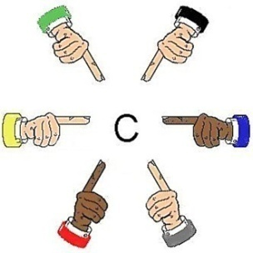  “Our center  is near me.”  “I think it's  right here.”  “I am the  center!"  Everyone could help locate our center.  A Chair with Balanced Support  CT can elect a chairperson or a few reps to serve as central swing voters between the factions on a council. To win, a candidate needs to earn wide-spread support. This gives her strong incentives to help the council balance its process and policies.  31 |  | How Does It Work?  To win, a policy must top each rival, one-against-one.  A good analogy is a round-robin tournament:  A player has one contest with each and every rival. If she wins all her tests, she wins the tournament.  Each voting test sorts all the ballots into two piles. If you rank option K over L, your ballot goes to K.  The option that gets the most ballots wins this test. If one wins all its tests* it wins the Condorcet Tally.  C tops A, C > B, C > D, C > E  A B  C  D E  Why Use Condorcet?.  Choice ballots: Rank all the options on one ballot. Simplify the old rules of order and speed up voting. Reduce agenda effects, from errors and gridlock,  to “free-rider” and “wrecking” amendments. page 33  No split-vote worries as duplicates don't help or hurt each other. A majority can rank all of their favorites  over the other options. Ballots from all voters help  decide which of the majority’s favorites wins.  A balanced policy tends to be stable, decisive. p. 31 Yet a balanced process can calm some fears about reviewing and changing a good policy to improve it. Both build respect for democracy.  * Instant Runoff can break a tie,  eg. if K > L, L > M, and M > K.  K L  .  M  IRV is the subject of another chapter.  30 |  | A Less Rigged Agenda Now!  Some meetings concoct a policy by a series of yes-no choices, with or without rules of order, agendas or votes. An early proposal might have to beat each later one. An early decision might preclude some later proposals. So “stacking the agenda” can help or hurt proposals.  Other meetings discuss the rival options all at once. But often some members express no backup choices. So similar options split supporters and hurt each other. Then a minority pushing 1 option can appear to be the strongest group. Even sadder, a member with a well-balanced option but few eager supporters might drop it.  Too often, a committee chooses all the parts in a bill. Other members can say only yes or no to that bundle.  Rigged votes often build bad policy and animosity. To reduce these risks, let the voters rank more options.¹  A Ranked Choice Ballot  1  Rank Option  3 Continue Discussion  2 Original Bill, the main motion  1 Bill with Amendment 1 (a free rider?)  8 Bill with Amend. 2 (a wrecking amend.?)  7 Bill with Amendments 1 and 2  4 Postpone for 7 days  5 Refer the Bill to a Committee  6 No Change (a vote for gridlock exposed?)  An “Incidental Motion” does not wait for the ballot,  e.g. a personal complaint or request. 33

| More pages in the free eBook. |
4. Condorcet Tally Centers a Policy  In a Condorcet tally, the winner must top all rivals,  one-against-one. Two games show how it works.  1) Flag L stands at our center, by the median voter. Flags J, K and M surround L, three feet from it.  We asked 9 voters: “Are you closer to J than to K? If so, please raise a hand.” Only one did.  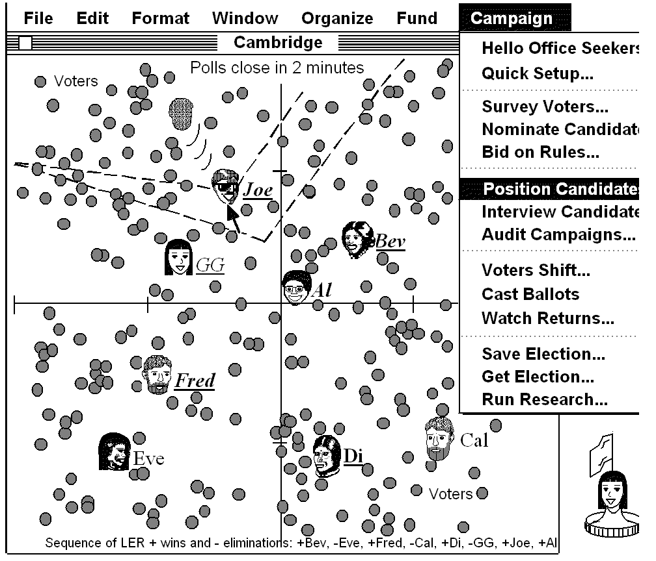  We entered J vs. K, etc. in the pairwise table below.  against J K L M  for J — 1 3 4  for K 8 8+1=9 4 5  for L 6 5 — 5  for M 5 4 4 4+5=9  The nine voters gave L a majority over each rival.  2) Flag L has a short Red ribbon and a long Blue one.  If the Red ribbon gets to you, the Red policy gets your vote with its narrow appeal.  But if the Red cannot touch you, the wide appeal of the Blue policy gets your vote. Which one wins?  If the flags are places for a heater in an icy cold room:  1. Do we put it at our center or in the biggest group?  2. Do we turn on its fan to spread the heat wide?  3. Do voters on the fringes have any influence?  4. Can the median voter enact any policy alone?  5. Do we get a balanced or a one-sided policy?  Usually: Blue. Center. Yes. Yes. No. Balanced. 45 | Watch Condorcet Find the Center  This simulation shows a line between Al and a rival. Voters on Al’s side of a line are closer to her and so rank her higher than the rival. The long line has more voters on Al’s side than on Joe’s. So Al wins that test. Al wins a very different majority over each rival here. To do that, Al's political positions must be central and have widespread support.  In contrast, PRCV requires the most intense support, first-rank votes, to avoid early elimination. Seepage 48.  RCV does too, with a high finish line of 50% + one vote.  56 | Complementing Consensus  Groups that seek consensus on basic agreements  may vote on other issues: They may vote on a detail  like a paint color or on a bunch of optional projects.  Voting only yes or no leads us to discuss and decide one formal “motion” at a time in a very strict sequence.  It stifles the sharing of ideas and development of plans.  Both consensus and ranked choice ballots let us decide some closely-related options at the same time. Both reward blending compatible ideas. pages 9, 31  They’re less divisive than yes-or-no voting. " 14, 45, 56  So more members want to help carry out the decision soon and make it work; fewer try to slow it down.  Why Take a Vote  Discussing an issue well often resolves most parts, with mandates up to 100%. Yet we might want to decide some parts with the best voting tools. Why?  The best rules strengthen some reasons for voting:  Choice ballots can speed up meetings. pages 27, 33  Secret ballots reduce social pressure and coercion.  Well-designed ballots and tallies promote equality:  Even busy or unassertive people can cast full votes.  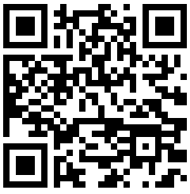  AccurateDemocracy.com/AcDem.pdf  Free  AccurateDemocracy.com/motions.htm  © 2023, by Robert Loring

